Otterburn Primary School

PSHE Curriculum Intent
At Otterburn Primary School we believe that PSHE and Citizenship should enable children to feel safe and happy and become healthy, responsible and valued citizens. All children are encouraged to aim high by developing their aspirations.
As we are a rural school, it is vital that our children have exposure to a range of cultures, beliefs and experiences in order that they have a wider view and understanding of the world they are growing up in and the opportunities that are available for them in the future.
We encourage our pupils to play a positive role in contributing to the life of the school and the wider community. This enables the children to develop their own self-worth. We ensure that the children experience the process of democracy through participation in the school parliament. Children are taught about their rights and responsibilities through our core values of the month.

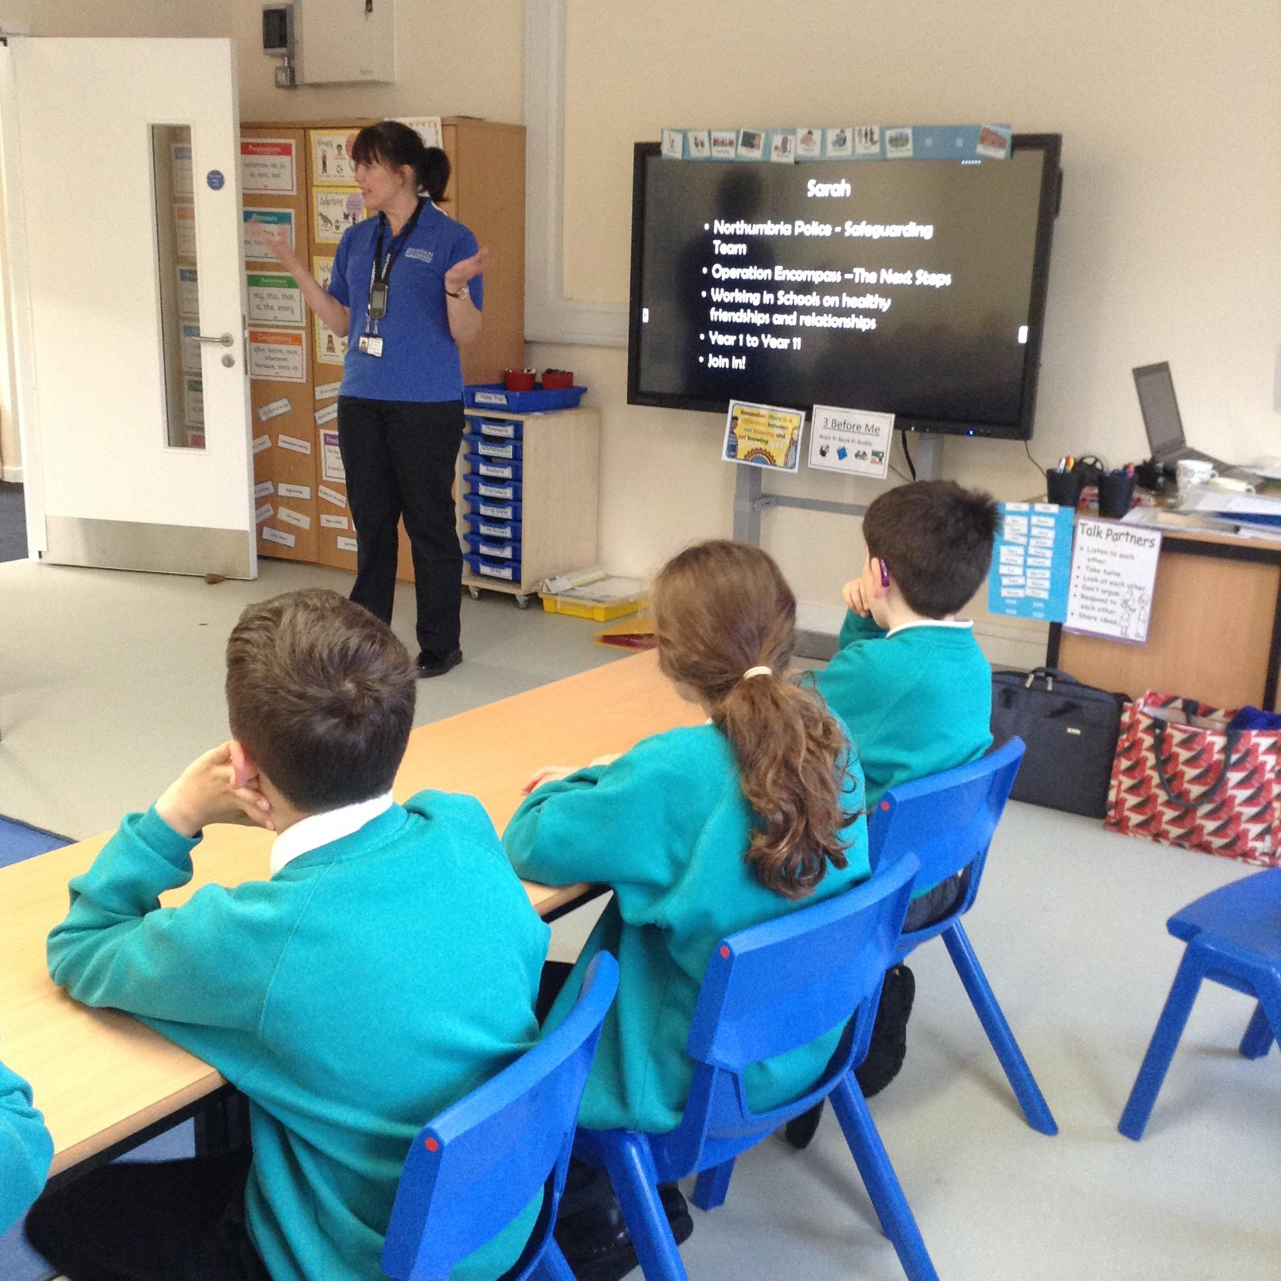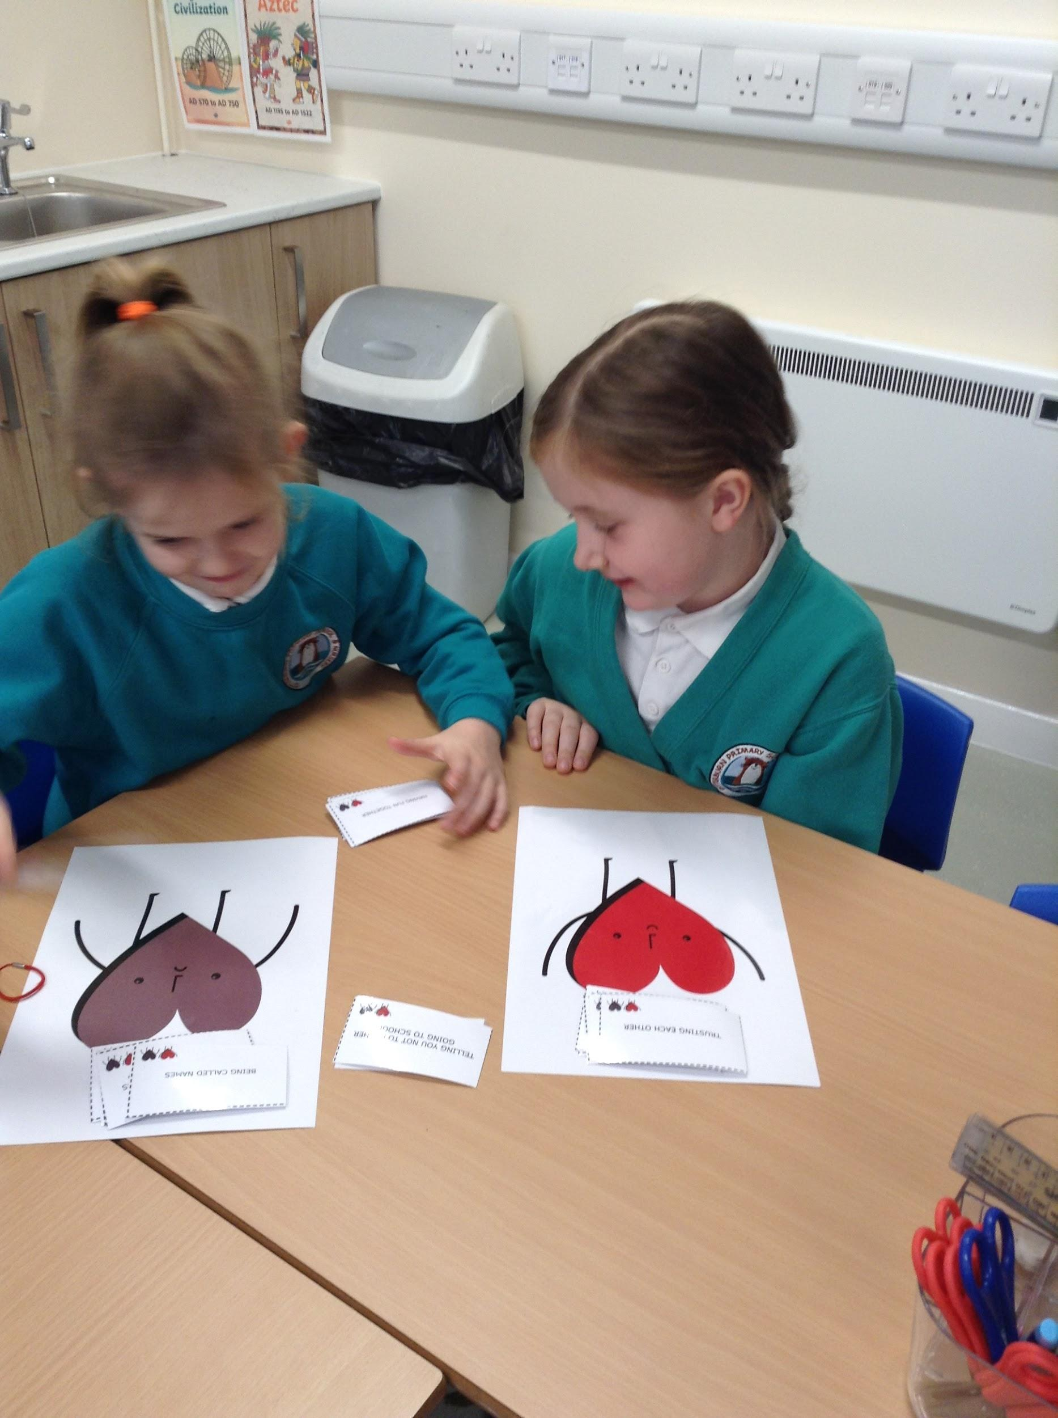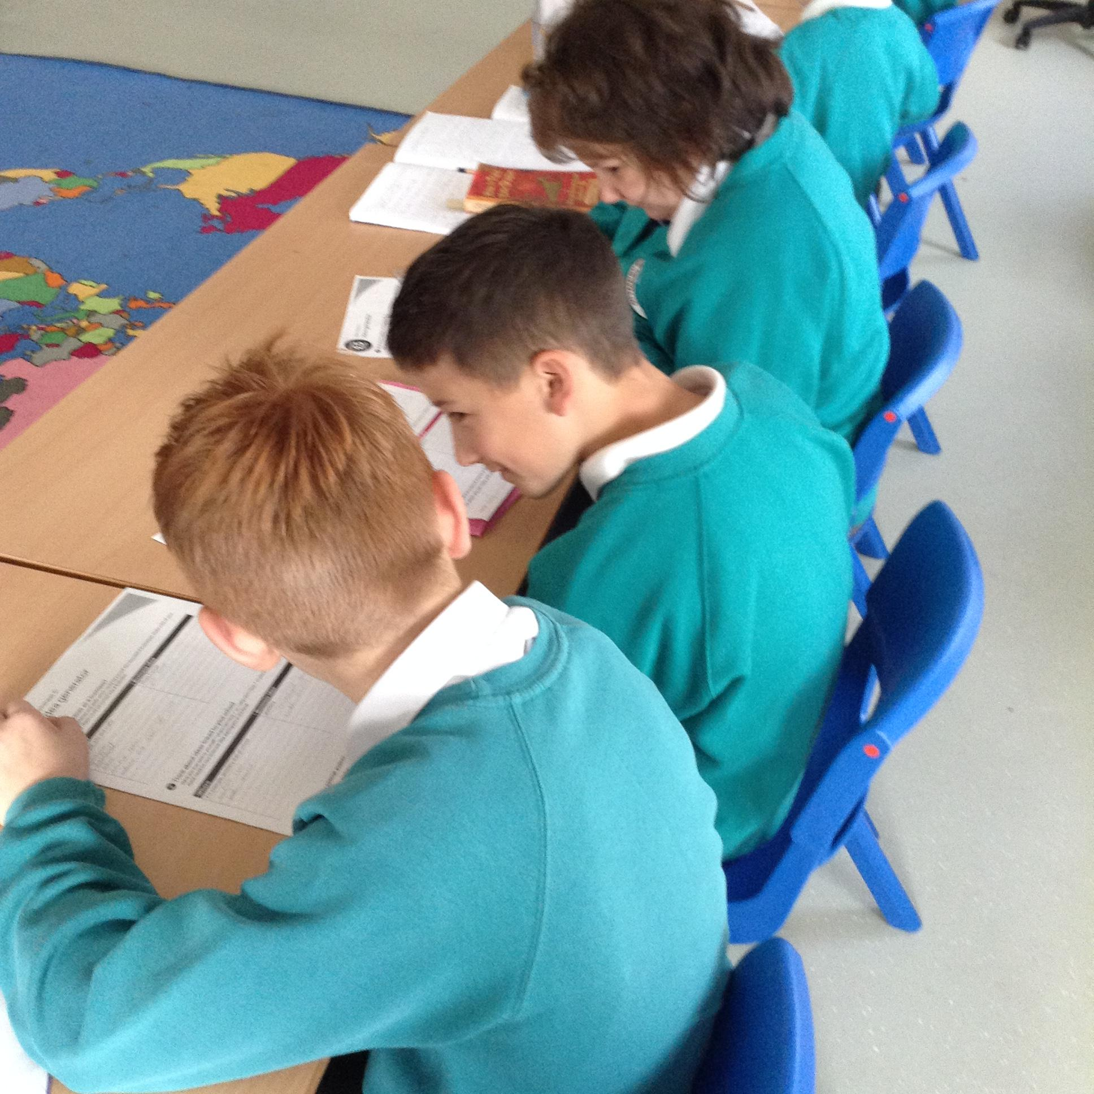

At Otterburn Primary, it is our intent that all children will be ‘lifelong learners’ with the confidence and ability to develop their skills and understanding when having new experiences, meeting new challenges and finding themselves in unfamiliar situations. We offer a nurturing learning environment in which each child is encouraged to develop their full potential and where their achievements and successes are celebrated and rewarded.
Implementation
As a school, we believe that children are all individuals and therefore, we aim to encourage mutual respect, responsibility and foster self-esteem in a happy and caring atmosphere. The teaching and learning of PSHE using the 3D PSHE Programme supports this, which also covers all the new 2020 statutory requirements for the teaching of Relationship and Health Education. All knowledge is built year on year and covers all aspects of health and wellbeing, relationships and living in the wider world using a two year cycle of planning. Through using this and through other whole school experiences/events, our children acquire knowledge, understanding and skills they need to manage their lives now and in their futures.
It develops the qualities and attributes children need to thrive as individuals, family members and members of society and the global community.
Our PSHE curriculum begins before the children step foot in the school with close communication with parents and EYFS settings and carries on through to when the children transfer to other settings.

Impact
At Otterburn we assess and monitor children’s progress through evidence in the learning environment, books and most importantly through pupil voice. It is our aim that all children are able to develop these life skills to support their personal development:
- Develop the knowledge and skills to enable them to become confident, healthy individuals- physically, emotionally and mentally.
- Develop a safe and healthy lifestyle including how to administer First Aid.
- Understand what makes a good relationship for others
- Have respect for others in school and in the outside world
- Develop own sense of self-esteem and emotional well-being and encourage others to do so
- To make the most of their own abilities
- Be independent and responsible members of a community, such as school
- Develop knowledge of ways in which individuals can contribute to society
- Develop self-confidence and self-esteem, and make informed choices regarding personal and social issues
- Develop good relationships with other members of the community
- Acquire enduring values and aspirations

